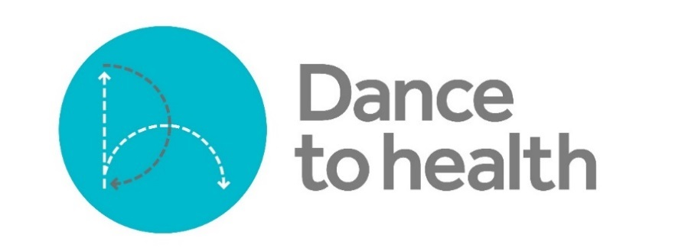
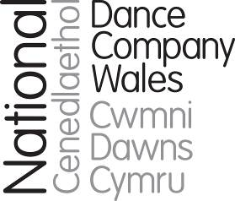

VOLUNTEER PEER MOTIVATOR ROLE DESCRIPTION

Project Name - Dance to Health

Project Overview
Dance to Health is a pioneering nationwide falls prevention dance programme for older people. Combining evidence and physiotherapy with the creativity, expression and energy of dance it reduces the risk of an older person suffering a fall. The scheme offers a solution to problems with existing falls prevention programmes.

Dance to Health groups are led by trained Dance Artists who embed evidence based falls prevention physiotherapy exercise in creative, fun, sociable dance sessions for older people who have been suffering falls or are at risk of falling.

Role Title
Volunteer Peer Motivator

Role Description
Peer Motivators is an essential role for every Dance to Health group. Peer Motivators are volunteers with interest in or experience of dance or keeping active. As a Peer Motivator, you will participate in the dance sessions, offering encouragement and support to other group members. As a part of the dance team delivering the project, your help will ensure that all participants get the one-to-one support they need to maximise the benefits of taking part.

Where & When

Dance to Health groups run weekly and each session lasts for 2 hours (90 minutes of activity and 30 minutes for refreshments and socialising). There will be sessions delivered across the Swansea region. Details of location will be agreed in next coming months.

Main Tasks
- Participate in Dance to Health group sessions, offering particular support, encouragement or one-to-one help to participants where required. For example, you may be asked to demonstrate seated options to less mobile participants.

- You will be part of the dance delivery team and the dance artist leading the sessions will direct you on how to help in each session.

- You may also help with collecting monitoring information from group participants – including offering help to complete membership forms or evaluation questionnaires to those who need it.

Skills/Experience Required
- Previous experience of taking part in dance is useful but not essential. You do need to be fit enough to take part in Dance to Health sessions.

- You need to be understanding, patient and empathetic, in order to be able to support group participants who need extra help and encouragement during sessions.

- Confidence with completing forms and paper work would be an advantage to help with monitoring information.

General Information

Further Information about the programme
Dance to health focuses on falls because:
- Falls represent the most frequent and serious type of accident in people aged 65 and over.
- 10% of ambulance calls are due to older people’s falls.
- After a fall, an older person is 50% likely to have seriously impaired mobility and 10% will die within a year.
- Falls destroy confidence, increase isolation and reduce independence.
- Falls cost the NHS £2.3 billion per year.

The standard falls prevention exercise programmes have problems. For example, only 40% who join standard falls prevention exercise, complete the course. Further, only 38% of such programmes are evidence-based practice, proven to reduce falls by 55%. Dance to Health has achieved 73% participants completing the programmes and is evidence-based. We also offer maintenance programmes which further strengthen its efficiency.

