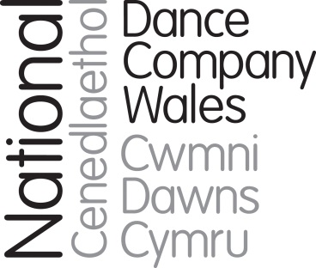

Brief for position of Finance Manager

December 2018

Marcos Morau’s Tundra, 2017

Background

NDCWales is one of the foremost national arts companies of Wales. It creates impact with work of the highest quality by working with exceptional UK and international choreographers, to reach and inspire audiences across Wales, the wider UK and around the world.

The Company is on a high after two years of extraordinary achievement which has raised its profile and enhanced its reach and reputation. 2017 saw the successful delivery of NDCWales’ most ambitious project to date – P.A.R.A.D.E. created with Marc Rees and a host of other artists to mark the centenary of the Russian Revolution. P.A.R.A.D.E was the icing on the cake of a year which has saw a surge in international profile with visits to Hong Kong, Germany (3 times) and Austria. A regularly funded organisation of the Arts Council of Wales, the Company has successfully diversified its funding base to raise funds from trusts, individuals and corporate sources.

A new 3-year grant enabled delivery of a small-scale tour and associated participation work, and the Company is co-producing a contemporary dance opera in Autumn 2018. A new post of Learning-lead Dancer works with the rest of the dancers and others to deliver excellent participatory work with people of all ages across Wales, and the wider UK.

The Company was founded as ‘Diversions’ in 1983. The Company grew in size and stature, mounting tours to China, Australia, India and many European countries. In 2004 the Company moved to a new purpose-built home, Dance House/Tŷ Dawns, as part of the new Wales Millennium Centre (WMC) and in 2009 the Company became National Dance Company Wales, reflecting its status and its role in leading and championing dance in Wales.

2015 saw the start of a new phase in the Company’s history with a new Chief Executive (Paul Kaynes), and latterly a new Artistic Director (Fearghus Ó Conchúir). The Company’s role as an ambassador for dance in Wales is vital to its new strategy, increasing the reach of its international touring and forging contacts and gathering knowledge which it brings back to Wales for the benefit of the wider dance sector.

The Dance House is the Company’s home and hub, acting as a centre for the creation and rehearsal of the Company’s work, a training base for the Company’s dancers and other dance artists, a space for hire as a rehearsal, creation and performance space, a centre for community activity and youth dance, and as a wider resource for the arts sector in Wales.

The Company

The Company is based at The Dance House/Tŷ Dawns in Cardiff, at the Wales Millennium Centre, where it has a dedicated rehearsal studio and performance space. There is currently a company of eight dancers and two student apprentice dancers who perform at base and at other venues in Wales, the wider UK and overseas. Company members also deliver a range of education and participation projects.

NDCWales creates dance which engages and resonates with audiences by being extraordinary and inclusive, working with the best dancers and choreographers from across Wales and beyond to make dance for stages large and small, in unusual spaces, and online.

We perform across Wales, the UK and around the globe, taking people on journeys of discovery, creating opportunities to participate, discuss, watch and learn about dance, about themselves and about the world. Our status as the national dance company is a privilege that informs everything we do: how we make work, who we work with and where work is placed. It is important that our programmes resonate with the diverse communities of Wales. Working in collaboration, we will ignite the spark of interest in dance with the widest range of promoters in every corner of the nation, building larger, broader audiences for dance.

NDC Wales is part of the Arts Council of Wales (ACW) portfolio. ACW is the Company’s major funder, awarding a revenue grant of £834,186 for 2018/19.

The key strategic priorities for our current business plan are:
- Developing the artistic vision with the interests/aspirations of audiences at the heart of our work, alongside our brand renewal and new approach to audience engagement
- Become an ‘all-Wales’ company creating the highest quality work with and for any and every community in the nation, entailing moving from an exclusive focus on touring to theatres of 250-900 seats only, to one which includes a dynamic and versatile model of presenting work which enables major collaborations, outdoor, smaller and larger scale touring, site specific work and community projects in a calendar which maximises the impact and exposure of the dancing company
- Revolutionising the Company’s approach to participation and learning, creating a more varied programme of activity which inspires and engages the people of Wales with the power of dance
- Fulfilling our role as a leader of dance in Wales, acting as an exemplar for the sector, recognised outside Wales, and bringing its knowledge and contacts home to make meaningful connections and create imaginative partnerships
- Securing the Company’s future through robust financial and operational management, always seeking out more efficient and effective ways to deliver everything we do
- Investing in the resources needed to tap into new income streams to deliver long-term stability for the Company, including income from trusts and foundations, individual donors, space and asset hire and box office/touring fees.

Structure and Governance

NDCWales is a registered charity with trustees who also act as directors of the Company. The

Board of NDCWales has a number of suitably qualified members who have an excellent track record of attendance and willingness to share their expertise and given their time for the good of the Company. There is currently one sub-committee, the Finance and General Purposes Committee (F&GP). Members are recruited through open advert and interview. The members of the Board include:
- Jane McCloskey, broadcaster and academic, with a strong background in creative industries development (F&GP Member)
- Emma Evans (F&GP member), dance producer and consultant
- Julie Hobday, experienced dance teacher and youth dance leader
- Gary Thomas, digital/film expert, staff member at British Council
- Matthew Gough, Senior Lecturer & Course Leader (Dance), University of South Wales
- Susan Coffey, Finance Manager (F&GP member)
- Huw Davies, Director of Finance, Welsh National Opera (F&GP member)

The Board is active between quarterly meetings to offer expertise, contacts, act as a sounding board for senior staff and making the Company aware of opportunities.

Our Work
Here are links to some recent works in the repertoire:
Folk by Caroline Finn: https://vimeo.com/155395220 (password folkdance)
Atalaӱ by Mario Bermudez Gil: https://vimeo.com/255073402 (password WatchTower)
Tundra by Marcos Morau https://vimeo.com/232690331
They Seek to Find the Happiness they Seem by Lee Johnston https://vimeo.com/83760961

The current pattern of touring sees the Company tour the UK middle-scale in Spring (February to May) each year whilst the Autumn is the main season for special projects and co-productions, such as Passion in 2018, and for the small-scale tour of Wales. Outdoor projects, and appearances in showcases such as Edinburgh and Tanzmesse take place, where possible, in the summer.
In addition to UK touring, the Company has a relationship with a German agent, Norddeutsche Konzertdirektion, booking tours of Germany, Austria, Switzerland. Recent tours have included Germany and Austria in April 2018 (Linz, Bonn, Leverkusen), Germany in July 2018 (Fürstenfeldbruck), with trips to Germany and Switzerland in December 2018 (Russelsheim, Schaffhausen, Schweinfurt), Poland in February 2019 (Krakow) and Germany and Austria in May 2019 and further trips being planned to the Asia Pacific area and South America.
Participation
There are three key elements to the Company’s participation programme with examples below:
- Schools and Education activity: workshops are offered in schools and colleges, for young people with little or no experience of dance, delivered either by company dancers, or by ambassadors in the locality of the venues visited, and specially trained and briefed to support our work and repertoire. Most of this work is offered at Primary School age (7-11 year olds). New partnerships enable the Company to reach schools without strong traditions of dance.
- Gifted and Talented Young People: the Company runs a youth company called the Associates, a group of 20 young people aged 13-19 who attend weekly classes and work towards presenting productions each year, showcased in annual youth dance showcases (for other youth companies as well as our own). There are week-long holiday courses for those wanting to develop technique, and by Dance Days during holiday periods for young people. In addition, the Company works with other agencies such as Rubicon Dance.
- Community activity: the Company works with a number of people and groups, for instance running two regular Dance for Parkinson’s Groups in Cardiff and the South Wales Valleys, in conjunction with English National Ballet. In addition, a new programme called Dance to Health targeted at older people at risk of falling is being delivered with a Welsh health board.
NDCWales – Our Audiences
Some key facts about our productivity and audiences/participants:
- The number of performances in 2017/18 was 80 (up from 35 in 2016/17)
- Of these 5 were international, 45 were in Wales and the remainder were in the rest of the UK
- 2017/18 number of live audiences and participants was 20,000 (trend is up, growing from 16,073 in 2016/17)
- Online and broadcast viewers were over 350,000, partly as result of BBC4 broadcast and The Space commission.

Recent Wales based research has shown most audiences are not dance loyal and on average will attend once every 2 years. Audiences are loyal to venues rather than the company. The figure below shows the last time NDCWales audiences attended a performance.

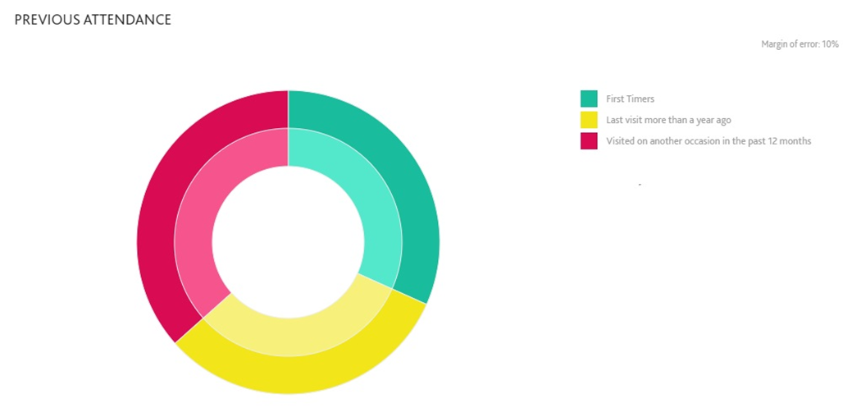

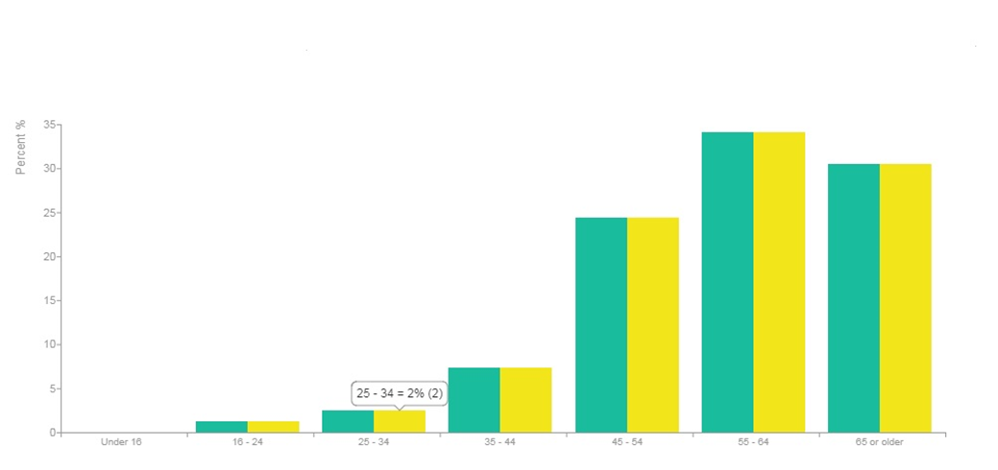
The average NDCWales audience in Wales and across the U.K are mostly middle aged, white collar, already highly engaged and is are confident arts attenders.
The Role of Finance Manager
National Dance Company Wales is one of the national arts companies of Wales. We make dance that aims to inspire audiences and participants across Wales, the wider UK and internationally. We are currently looking to appoint an experienced finance professional to the new, part-time post of Finance Manager, around 30 hours a week, which could be worked flexibly across 5 days.

As the lead finance professional for the organisation, the post holder will report to the Operations Director and will line-manage the Finance Officer. The post-holder will be expected to work closely with the Senior Leadership Team and the Board of Trustees. The key areas of the post are budgeting, management accounting, cashflow management, financial analysis and statutory reporting.

NDCWales aim to be a diverse and vibrant Company and welcome applications from people of all backgrounds.

Duties and responsibilities

Key areas of the post:
- Business planning
- Financial resources
- Managing staff
- Reporting to Board

Business planning and performance
- Lead on finance management, contributing to strategic business planning ensuring the most effective use of financial and other resources, and advise the Board and Senior Management in these areas
- Devising and managing the implementation of financial information as part of company strategy
- Reviewing and updating financial policies and procedures, in conjunction with F&GP.
Making the most effective and efficient use of financial and other resources
- Prepare management accounts on a monthly basis, consulting with Chief Executive and management team on issues arising
- Lead budget creation process each year with SLT and Chief Executive, monitoring budget against performance and re-forecasting
- Lead on cash flow management, preparing cash flow forecasts
- Monitor corporate reporting to ensure the timely compliance with all necessary financial requirements of stakeholders and governing bodies; e.g. ACW, Companies House, Charity Commission etc.
- To work with the F&GP and Chief Executive to maintain a Financial Risk Management policy for the organisation
- Input to funding applications and management of statutory and charitable grants, overseeing and reporting on restricted funds
- Lead on the annual theatre tax relief claim, ensuring the Company is maximising its claims, and that claims are submitted as soon as possible after year-end
- Oversee preparation and submission of Gift Aid claims
- Seeking out opportunities for income development, from commercial activities, fees charged for various activities, and from making the best use of cash investments
- To be responsible for Audit. To ensure that appropriate financial policies and controls are in place using criteria set under the Charities SORP to support financial decision-making, ensuring compliance with appropriate regulations and good practice. To liaise with the external auditors, currently responsible for preparing the Statutory Accounts, regarding the audit process and the production of the statutory accounts
- Reviewing VAT return before submission
- Ensure that legislation, best practice, timely reporting and systems controls are effected to optimise financial control and analysis
- Managing and calculating yearly depreciation costs.

Managing Finance Officer
- Managing and supporting the Finance Officer who oversees the purchase and sales ledger, banking, payroll as well as general HR and Finance administration
- Performance management and identifying training and professional development needs of Finance Officer.
Reporting to the Board committees
- Attend Finance and General Purposes Committee meetings (currently 4 times a year) to present Management Accounts, reporting on key issues.

General duties
- Act as a role model for all employees in terms of professional conduct, standards and policies
- Undertake other duties reasonably expected to fulfil the role.

Person specification
The successful candidate should be a fully qualified ACCA/CIMA/CCAB accountant with demonstrable post qualification experience, or otherwise qualified by relevant experience in a similar sized not for profit organisation.

Skills and experience

Essential
- Fully qualified ACCA/CIMA/CCAB accountant
- Experience of successful and creative financial management in a senior role in the commercial or not-for-profit sector
- Knowledge of Accounting Packages
- Knowledge of accounting standards
- Significant experience in financial accounting and VAT
- Experience of producing management accounts and final accounts, and managing an audit
- Proven ability to lead, manage, support and motivate staff
- Able to direct the work of a key department and to act on own initiative
- Excellent oral and written communication skills
- Excellent analytical and interpretation skills, evidenced by experience of analysing and interpreting complex data for presentation to trustees and management
- Excellent relationship building, influencing and networking skills within the organisation as a whole and with other stakeholders

Desirable
- Experience of making Theatre Tax Relief Claims and Gift Aid Claims
- Payroll experience
- Familiarity with Sage Accounting Package
- Knowledge of charities SORP’s
- Experience of operational support and development of IT systems
- Ability to communicate in the Welsh language, both spoken and written.

Terms and conditions

The terms and conditions are indicative of a full-time appointment and would be negotiated accordingly for any joint or job-share appointment.

Salary: £33,000-35,000 per annum pro rata depending on experience

Pension: NDCWales currently contributes 5% of salary to a pension with Royal London, dependent on employee’s matching contribution

Contract: Permanent employment contract

Hours: Part-time. Equivalent to 3 or 4 days per week; flexible hours. TOIL is available for hours outside the ordinary

Place of work: Cardiff. We expect the post-holder to live locally

Holidays: 28 days pro rata plus 8 public holidays (3 of these days pro rata will be taken between Christmas and New Year)

Any offer of employment will be subject to the receipt of:
  - Satisfactory References
  - Evidence of right to work in the UK as defined by the Home Office
There will be a three-month probationary period, during which time regular monitoring meetings will be held with relevant representatives.
How to apply

Please apply by submitting the application form.

Please also indicate if you are an EU national or if you would require a visa.

Closing date for applications 12 noon, 14 January 2019.

Please e-mail Rebecca Hobbs at rebecca@ndcwales.co.uk to request this pack in Welsh or in another format.

