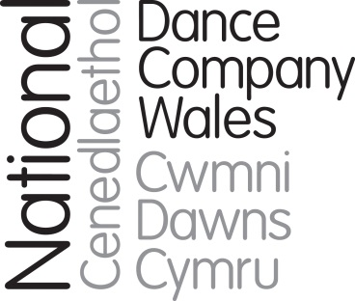

Brief for position of Tour and Projects Officer

April 2019

Marcos Morau’s Tundra, 2017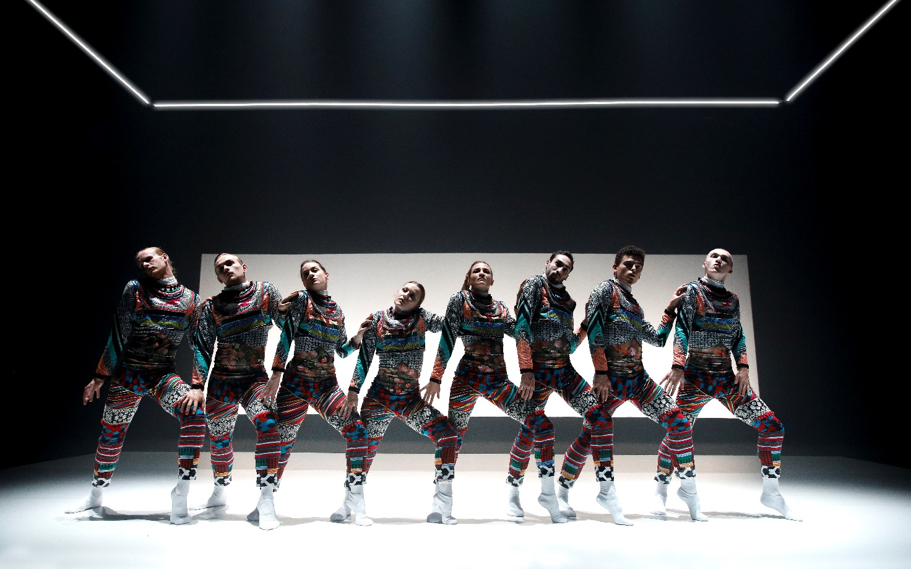

Background

NDCWales is one of the foremost national arts companies of Wales. It creates impact with work of the highest quality by working with exceptional UK and international choreographers, to reach and inspire audiences across Wales, the wider UK and around the world.

The Company is on a high after two years of extraordinary achievement which has raised its profile and enhanced its reach and reputation. 2017 saw the successful delivery of NDCWales’ most ambitious project to date – P.A.R.A.D.E. created with Marc Rees and a host of other artists to mark the centenary of the Russian Revolution. P.A.R.A.D.E was the icing on the cake of a year which saw a surge in international profile with visits to Hong Kong, Germany (twice) and Austria. A regularly funded organisation of the Arts Council of Wales, the Company has successfully diversified its funding base to raise funds from trusts, individuals and corporate sources.

A new 3-year grant enabled delivery of a small-scale tour and associated participation work, allowing a new post of Learning-lead Dancer which works with the rest of the dancers and others to deliver excellent participatory work with people of all ages across Wales, and the wider UK.

The Company was founded as ‘Diversions’ in 1983. The Company grew in size and stature, mounting tours to China, Australia, India and many European countries. In 2004 the Company moved to a new purpose-built home, Dance House/Tŷ Dawns, as part of the new Wales Millennium Centre (WMC) and in 2009 the Company became National Dance Company Wales, reflecting its status and its role in leading and championing dance in Wales.

2015 saw the start of a new phase in the Company’s history with a new Chief Executive (Paul Kaynes), and latterly a new Artistic Director (Fearghus Ó Conchúir). The Company’s role as an ambassador for dance in Wales is vital to its new strategy, increasing the reach of its international touring and forging contacts and gathering knowledge which it brings back to Wales for the benefit of the wider dance sector.

The Dance House is the Company’s home and hub, acting as a centre for the creation and rehearsal of the Company’s work, a training base for the Company’s dancers and other dance artists, a space for hire as a rehearsal, creation and performance space, a centre for community activity and youth dance, and as a wider resource for the arts sector in Wales.

The Company

The Company is based at The Dance House/Tŷ Dawns in Cardiff, at the Wales Millennium Centre, where it has a dedicated rehearsal studio and performance space. There is currently a company of eight dancers and two student apprentice dancers who perform at base and at other venues in Wales, the wider UK and overseas. Company members also deliver a range of education and participation projects.

NDCWales creates dance which engages and resonates with audiences by being extraordinary and inclusive, working with the best dancers and choreographers from across Wales and beyond to make dance for stages large and small, in unusual spaces, and online.

We perform across Wales, the UK and around the globe, taking people on journeys of discovery, creating opportunities to participate, discuss, watch and learn about dance, about themselves and about the world. Our status as the national dance company is a privilege that informs everything we do: how we make work, who we work with and where work is placed. It is important that our programmes resonate with the diverse communities of Wales. Working in collaboration, we will ignite the spark of interest in dance with the widest range of promoters in every corner of the nation, building larger, broader audiences for dance.

NDC Wales is part of the Arts Council of Wales (ACW) portfolio. ACW is the Company’s major funder, awarding a revenue grant of £834,186 for 2018/19.

The key strategic priorities for our current business plan are:
- Developing the artistic vision with the interests/aspirations of audiences at the heart of our work, alongside our brand renewal and new approach to audience engagement
- Become an ‘all-Wales’ company creating the highest quality work with and for any and every community in the nation, entailing moving from an exclusive focus on touring to theatres of 250-900 seats only, to one which includes a dynamic and versatile model of presenting work which enables major collaborations, outdoor, smaller and larger scale touring, site specific work and community projects in a calendar which maximises the impact and exposure of the dancing company
- Revolutionising the Company’s approach to participation and learning, creating a more varied programme of activity which inspires and engages the people of Wales with the power of dance
- Fulfilling our role as a leader of dance in Wales, acting as an exemplar for the sector, recognised outside Wales, and bringing its knowledge and contacts home to make meaningful connections and create imaginative partnerships
- Securing the Company’s future through robust financial and operational management, always seeking out more efficient and effective ways to deliver everything we do
- Investing in the resources needed to tap into new income streams to deliver long-term stability for the Company, including income from trusts and foundations, individual donors, space and asset hire and box office/touring fees.

Structure and Governance

NDCWales is a registered charity with trustees who also act as directors of the Company. The

Board of NDCWales has a number of suitably qualified members who have an excellent track record of attendance and willingness to share their expertise and given their time for the good of the Company. There is currently one sub-committee, the Finance and General Purposes Committee (F&GP). Members are recruited through open advert and interview. The members of the Board include:
- Jane McCloskey, broadcaster and academic, with a strong background in creative industries development (F&GP Member)
- Emma Evans (F&GP member), dance producer and consultant
- Gary Thomas, digital/film expert, staff member at British Council
- Matthew Gough, Senior Lecturer & Course Leader (Dance), University of South Wales
- Susan Coffey, Finance Manager (F&GP member)
- Huw Davies, Director of Finance, Welsh National Opera (F&GP member)

The Board is active between quarterly meetings to offer expertise, contacts, act as a sounding board for senior staff and making the Company aware of opportunities.

Our Work
Here are links to some recent works in the repertoire:
Folk by Caroline Finn: https://vimeo.com/155395220 (password folkdance)
Atalaӱ by Mario Bermudez Gil: https://vimeo.com/255073402 (password WatchTower)
Tundra by Marcos Morau https://vimeo.com/232690331
In Autumn 2018, the Company created a co-production with Music Theatre Wales of the dance opera Passion by Pascal Dusapin – which includes dance content choreographed by the Company’s Resident Choreographer, Caroline Finn.
The current pattern of touring sees the Company tour the UK middle-scale in Spring (February to May) each year whilst the Autumn is the main season for special projects and co-productions, such as Passion in 2018, and for the small-scale tour of Wales. Outdoor projects, and appearances in showcases such as Edinburgh and Tanzmesse take place, where possible, in the summer.
In addition to UK touring, the Company has a relationship with a German agent, Norddeutsche Konzertdirektion, booking tours of Germany, Austria, Switzerland. Recent tours have included Germany and Austria in April 2018 (Linz, Bonn, Leverkusen), Germany in July 2018 (Fürstenfeldbruck), Poland in February 2019 (Krakow), with further trips being planned to the Asia Pacific area and South America.
Participation
There are three key elements to the Company’s participation programme with examples below:
- Schools and Education activity: workshops are offered in schools and colleges, for young people with little or no experience of dance, delivered either by company dancers, or by ambassadors in the locality of the venues visited, and specially trained and briefed to support our work and repertoire. Most of this work is offered at Primary School age (7-11 year olds). New partnerships enable the Company to reach schools without strong traditions of dance.
- Gifted and Talented Young People: the Company runs a youth company called the Associates, a group of 20 young people aged 13-19 who attend weekly classes and work towards presenting productions each year, showcased in bi-annnual youth dance showcases (for other youth companies as well as our own). There are week-long holiday courses for those wanting to develop technique, and by Dance Days during holiday periods for young people. In addition the Company works with other agencies such as Rubicon Dance.
- Community activity: the Company works with a number of people and groups, for instance running two regular Dance for Parkinson’s Groups in Cardiff and the South Wales Valleys, in conjunction with English National Ballet. In addition a new programme called Dance to Health targeted at older people at risk of falling is being delivered with a Welsh health board.
NDCWales – Our Audiences
Some key facts about our productivity and audiences/participants:
- The number of performances in 2017/18 was 80 (up from 35 in 2016/17)
- Of these 5 were international, 45 were in Wales and the remainder were in the rest of the UK
- 2017/18 number of live audiences and participants was 20,000 (trend is up, growing from 16,073 in 2016/17)
- Online and broadcast viewers were over 350,000, partly as result of BBC4 broadcast and The Space commission.

Recent Wales based research has shown most audiences are not dance loyal and on average will attend once every 2 years. Audiences are loyal to venues rather than the company. The figure below shows the last time NDCWales audiences attended a performance.

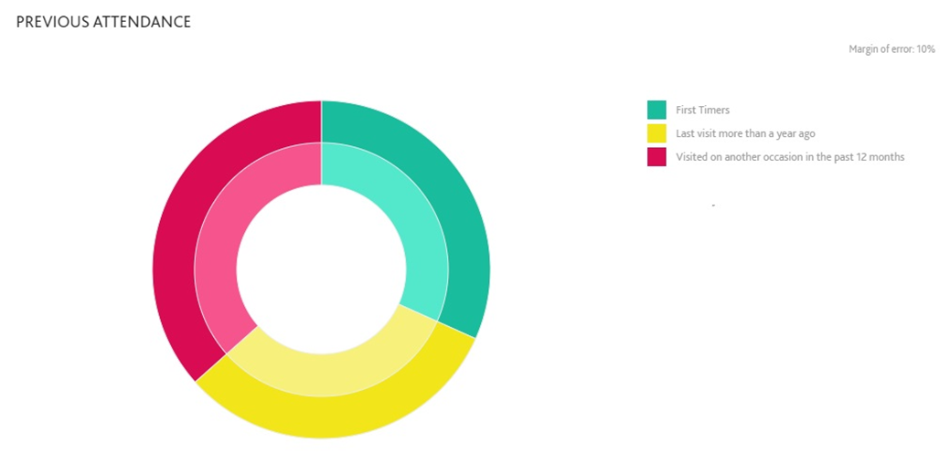

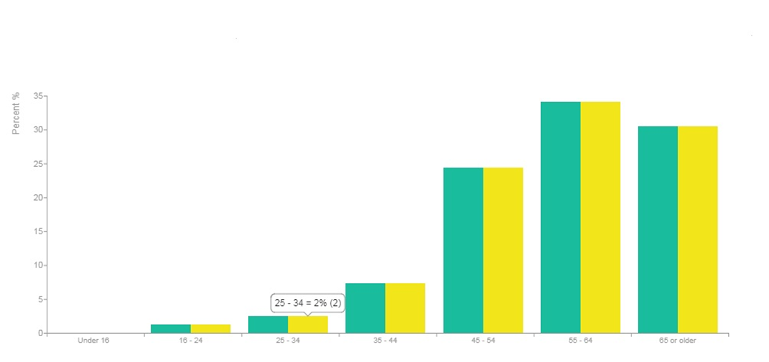
The average NDCWales audience in Wales and across the U.K are mostly middle aged, white collar, already highly engaged and is are confident arts attenders.
The Role of Tour and Projects Officer

National Dance Company Wales is one of the national arts companies of Wales. We make dance that aims to inspire audiences and participants across Wales, the wider UK and internationally. We are currently looking to appoint a Tour and Projects Officer to work closely with the Tour and Projects Producer and the Production Manager to administrate the Company’s programme of activity.

NDCWales aim to be a diverse and vibrant Company and welcome applications from people of all backgrounds

Duties and responsibilities

The purpose of the post is to administrate the Company’s programme, including:
- Touring and Projects administration
- Production administration
- Dance House
- General duties

Touring and Projects administration
- Act as the touring administrator ensuring the Company’s internal scheduling system is kept up to date, booking travel and accommodation for tour, putting together touring information packs
- Liaise with venue managers/programmers to follow up agreements negotiated by the Tour and Projects Producer
- Support the Learning and Participation Producer with administration for project and workshop activity.

Production administration
- Administration of Company productions including booking travel and accommodation for artists, ensuring all contracts are signed

Dance House
- Manage bookings for hire of spaces and studios; including contracting
- Maintain a clear and up to date schedule of all hires making sure that the Company’s internal calendar is kept up to date
- Work in liaison with the technical department to ensure the smooth running of Dance House events and activity
- Organise staffing for Dance House events and activity. Overseeing the Events Assistants and organising timesheets.

General duties
- Budget Management
- Attend and minute company meetings as required
- Act as a role model for all employees in terms of professional conduct, standards and policies.
- Undertake other duties reasonably expected.

Person specification

Skills and experience

Essential
- Discretion and excellent interpersonal skills
- Ability to use own initiative
- Well organised with experience of diary management
- Attention to detail
- Experience of managing/overseeing budgetary expenditure.
- Experience of managing relationships with people at all levels.

Desirable

- Interest in dance
- Project planning experience
- An understanding of the dance touring sector

- Welsh speaker

Company Values

It is essential that all staff members demonstrate active promotion of the Company’s values. The six values are:

Curious and Pioneering

Inclusive and Versatile

Collaborative and Ambitious

Terms and conditions

The terms and conditions are indicative of a full-time appointment and would be negotiated accordingly for any joint or job-share appointment.

Salary: Salary £18,000 per annum pro rata

Pension: NDCWales currently contributes 5% of salary to a pension with Royal London, dependent on employee’s matching contribution

Contract: Permanent employment contract

Hours: This is a part-time permanent position of 4 days per week, actual hours can be flexible. We also welcome job share proposals. TOIL is available for hours outside the ordinary.

Place of work: Cardiff

Holidays: 28 days per annum pro rata plus public holidays (3 of these days must be taken between Christmas and New Year)

We expect the post-holder to live locally.

Any offer of employment will be subject to the receipt of:
  - Satisfactory References
  - Evidence of right to work in the UK as defined by the Home Office
There will be a three-month probationary period, during which time regular monitoring meetings will be held with relevant representatives.
How to apply

Please apply by submitting the online application form.

Please also indicate if you are an EU national or if you would require a visa.

Closing date for applications 12 noon, Thursday 9 May 2019

Interviews will be held w/c 13 May 2019

If you would prefer to submit a video application, please send us a link via You Tube or Vimeo or share the video with us via your preferred file sharing service. Please make sure you answer all the questions on the application form on the website.

Please e-mail Rebecca Hobbs at rebecca@ndcwales.co.uk to request this pack in Welsh or in another format.

